PIRELLI TYRE ORDER
FIA ERC - RALLY LIEPAJA 2015

TEAM/DRIVER _________________________________________________________

CONTACTS _________________________________________________________
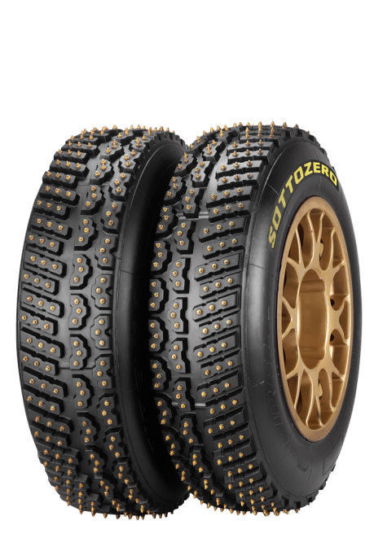

TYRE | SIZE | PRICE w/o VAT | QTY
SOTTOZERO ICE LEFT | 205/65R15 | 350.00 €
SOTTOZERO ICE RIGHT | 205/65R15 | 350.00 €

This studded tyre is designed exclusively for FIA WRC & FIA ERC, and is meant for snowy and icy stages. The 380 studs ensure high grip even in the most severe conditions. The tyre benefits from Pirelli’s patented stud retention technology, where the compound design is specifically engineered to prevent the loss of studs during the stage.

Comments / Notes ________________________________________________________________

~~~~~~~~~~~~~~~~~~~~~~~~~~~~~~~~~~~~~~~~~~~~~~~~~~~~~~~~~~~~~~~~~~~~~~~~~~~~~~

All preordered tyres must be prepaid via bank transfer before delivery.
During event tyres will be available at Service Park for purchase with additional VAT 21%
Cash - Euro
Card - Visa, Master Card

~~~~~~~~~~~~~~~~~~~~~~~~~~~~~~~~~~~~~~~~~~~~~~~~~~~~~~~~~~~~~~~~~~~~~~~~~~~~~~~

Completed form send to:
sport@latakko.lv

For more information please contact:

Girts Lagzdins
LATAKKO, Ltd
Mob: +371 27833354
sport@latakko.lv

